School Curriculum Workshops

We now offer curriculum based, on-site workshops to local schools, teaching whole year groups within their school setting. We work with class teachers to create clay workshops specific to the curriculum and deliver two, 2 hour workshops in clay over the course of the school day on themes such as Viking Boats, Canopic Jars and Greek Pots. We provide all the resources and clay needed and at the end we take the work back to the Leach Pottery to be dried and fired in our electric kiln.
These projects have been hugely successful in encouraging participation from all ability learners within mainstream school, linking in ideas of design and creativity within the school curriculum.

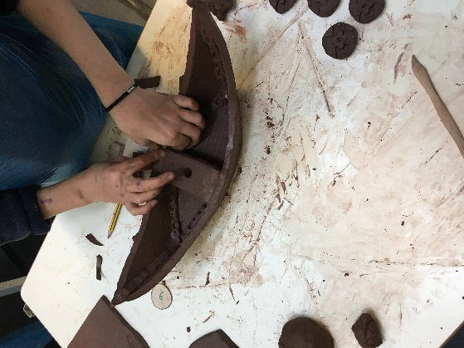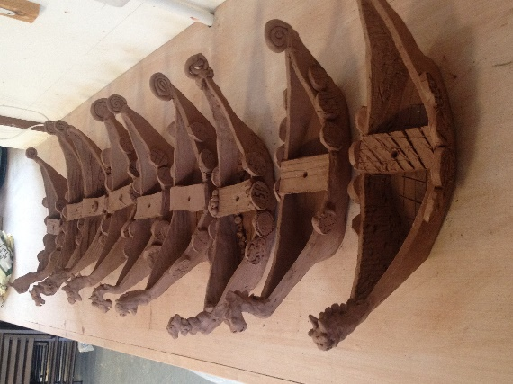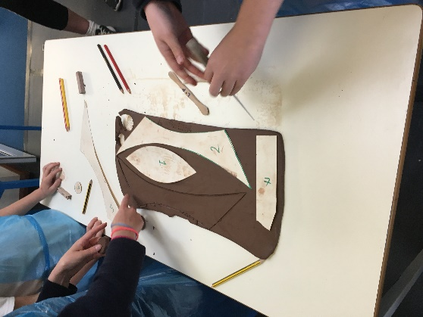
Viking boats, St Ives Junior School, 2016

Outline:
Full Day Workshop split into 2 sessions; 10am-12am and 1pm-3pm.
Up to 60 students, (30 in each session) accompanied by 2-4 class teachers/ TAs depending on age and ability of the children.
Costs include; planning and delivery of workshops by 2 Leach Pottery teaching staff; setting up of workshop space; all resources, tools and materials and the firing and glazing of the work.
COST: £450

